1. **Project Overview:**

The project is a Social Media Analytics Platform designed to track, analyze, and provide insights into social media activities. The platform collects data from multiple social media sources (such as Twitter, Instagram, Facebook) and processes it to generate useful analytics like engagement rates, sentiment analysis, follower demographics, etc. The goal is to help businesses, marketers, and influencers optimize their social media strategies based on data-driven insights.

2. **Identify Entities and Attributes:**

1. **User**

**Attributes:**

User_ID (Primary Key)

Name

Email

Join_Date

Profile_Type (Individual/Business)

2. **Social Media Platform**

**Attributes:**

Platform_ID (Primary Key)

Platform_Name (e.g., Twitter, Facebook, Instagram)

Type (e.g., Social Networking, Microblogging)

Launch_Date

Number_of_Users

3**. Post**

**Attributes:**

Post_ID (Primary Key)

Content

Post_Date

Likes_Count

Shares_Count

User_ID (Foreign Key from User)

4. **Analytics**

**Attributes:**

Analytics_ID (Primary Key)

Post_ID (Foreign Key from Post)

Engagement_Rate

Sentiment_Score

Hashtags_Used

5. **Follower**

**Attributes:**

Follower_ID (Primary Key)

Follower_Name

Follow_Date

Follower_Type (Individual/Business)

User_ID (Foreign Key from User)

6. **Campaign**

**Attributes:**

Campaign_ID (Primary Key)

Campaign_Name

Start_Date

End_Date

Budget

3. **Define Relationships**

1. **User - Post**

Degree: 2 (User, Post)

Cardinality: One-to-Many (One User can create many Posts, but each Post is created by only one User)

2. **Post - Analytics**

Degree: 2 (Post, Analytics)

Cardinality: One-to-One (Each Post has one set of Analytics data)

3. **User - Follower**

Degree: 2 (User, Follower)

Cardinality: One-to-Many (A User can have multiple Followers, but each Follower follows one User)

4. **Social Media Platform - Post**

Degree: 2 (Social Media Platform, Post)

Cardinality: One-to-Many (A Social Media Platform hosts multiple Posts, but each Post is associated with one Social Media Platform)

5. **Campaign - Post**

Degree: 2 (Campaign, Post)

Cardinality: One-to-Many (A Campaign can have multiple Posts, but each Post is part of one Campaign)

4.**ER Diagram**

Here’s a textual representation of the ER diagram (due to limitations in visuals):

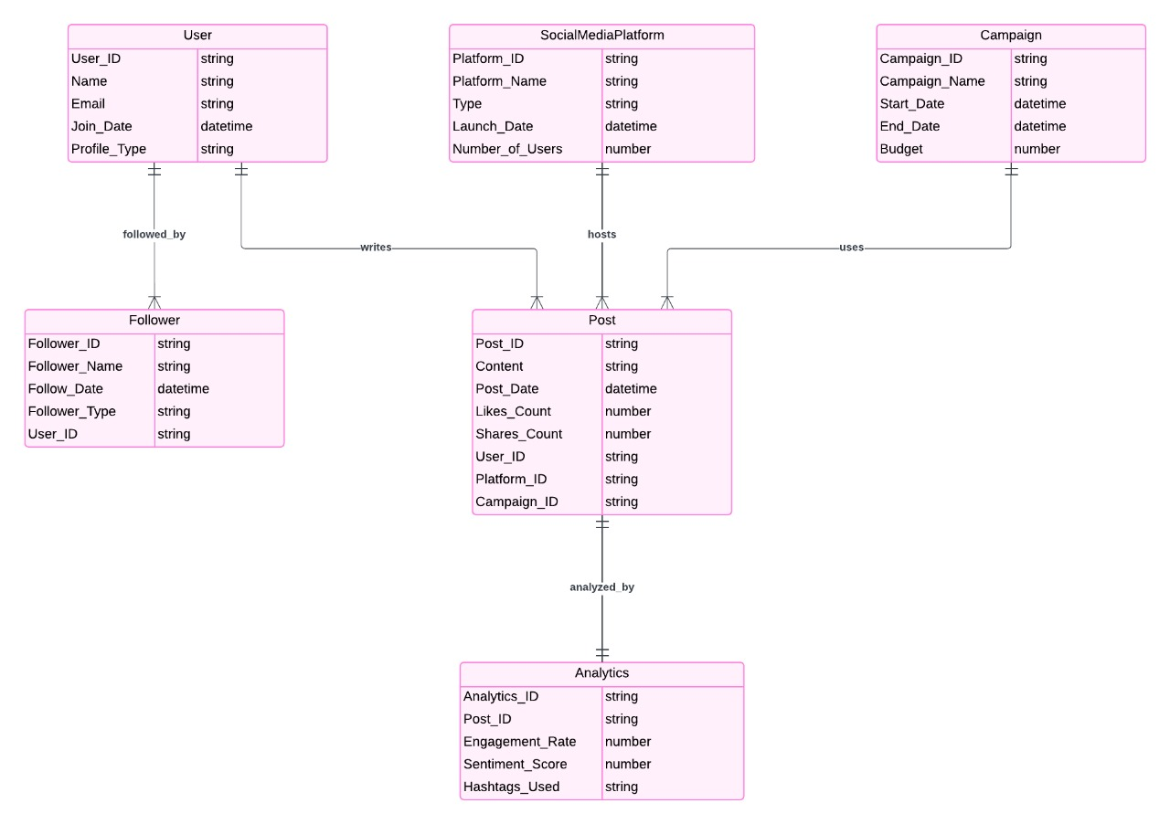

**ER Diagram Explanation:**

This ER (Entity-Relationship) diagram represents a social media database model with six entities: User Follower ,SocialMediaPlatform, Campaign Post, and Analytics Here’s a breakdown of each entity and their relationships:

**Entities and Attributes**

1. **User**

Attributes: `User_ID` (primary key), `Name`, `Email`, `Join_Date`, `Profile_Type`.

Represents individual users of the social media platform.

Each user has a unique ID, and additional attributes like their name, email, join date, and profile type (e.g., personal or business).

2. **Follower**

**Attributes:** `Follower_ID`, `Follower_Name`, `Follow_Date`, `Follower_Type`, `User_ID`.

Represents a user's follower with a unique follower ID and additional details such as the follower's name, follow date, and follower type.

The `User_ID` attribute links to the User table, indicating the user that is being followed.

3. **SocialMediaPlatform**

**Attributes**: `Platform_ID` (primary key), `Platform_Name`, `Type`, `Launch_Date`, Number_of_Users`.

Represents the social media platform where posts and campaigns are hosted.

Each platform has a unique ID, name, type (e.g., social, professional), launch date, and total number of users.

4. **Campaign**

**Attributes:** `Campaign_ID` (primary key), `Campaign_Name`, `Start_Date`, `End_Date`, `Budget`.

Represents marketing or ad campaigns running on the platform.

Each campaign has a unique ID, a name, start and end dates, and a budget.

5. **Post**

Attributes: `Post_ID` (primary key), `Content`, `Post_Date`, `Likes_Count`, `Shares_Count`, `User_ID`, `Platform_ID`, `Campaign_ID`.

Represents a post made by a user on a social media platform.

Contains details like the post content, date, number of likes, shares, and references to the user who created it, the platform where it was posted, and any associated campaign.

6. **Analytics**

**Attributes:** `Analytics_ID` (primary key), `Post_ID`, `Engagement_Rate`, `Sentiment_Score`, `Hashtags_Used`.

Represents analytics data related to a specific post.

Each record includes the post ID, engagement rate, sentiment score, and hashtags used.

**Relationships**

1. **User – Follower (followed_by):**

This is a one-to-many relationship, indicating that a User can have multiple Followers

2. **User – Post (writes):**

A one-to-many relationship, showing that a User can create multiple Posts

3. **SocialMediaPlatform –Post (hosts):**

A one-to-many relationship, where a SocialMediaPlatform can host multiple Posts.

4. **Campaign – Post (uses):**

A one-to-many relationship, indicating that a Campaign can include multiple Posts.

5. **Post – Analytic (analyzed by):**

A one-to-one relationship, showing that each Post has a corresponding Analytics entry.

This ER diagram models a social media environment, with users who follow each other, create posts on various platforms, and participate in campaigns. Analytics are tracked for each post to measure engagement, sentiment, and hashtag usage.